**INDIAN INSTITUTE OF TECHNOLOGY, BOMBAY**



**Department of Aerospace Engineering**

**October 20, 2022**

**AE 725 : Air Transportation**

**ASSIGNMENT III**

**CLT AIRPORT**

**Course Instructor**

*Prof. R. K. Pant*

**Submitted by**

*Team 08*

Contents

List of Figures 3

List of Tables 4

Chapter 1: Wind Rose Diagram 4

Historic Wind Data 5

Type-I Wind Rose Diagram 5

Coverage provided by Runways 6

Chapter 2: Declared Distances 12

Declared Distances of Runways 12

Critical Runway 13

Temperature Data 14

Runway Length Corrections 15

REFERENCES 18

# List of Figures

Figure 1: Wind Rose Diagram for period of 5 years from 1 January 2017 to 1 January 2022. Calm Values <2 mph compromise of around 13.29% total. 1

Figure 2: Runways of Charlotte Douglas International Airport, Chicago 3

Figure 3: Wind Coverage for three parallel runways 4

[Figure 4: Wind Coverage for one runway 5](https://iitbacin-my.sharepoint.com/personal/22d0271_iitb_ac_in/Documents/Courses/Semester%201/AE%20725/Assignment_03.docx#_Toc117194135)

Figure 5: Wind Coverage for cross runways 6

Figure 6: Elevation Plot 12

# List of Tables

Table 1: Grouped speed data table for a period of 5 years (1st Jan 2017 to 1st Jan 2022) 1

Table 2: Grouped speed data table for a period of 1 year (1st Jan 2021 to 1st Jan 2022) 2

Table 3: Declared Distances of all the runways of CLT airport 7

Table 4: Gradient Calculation 11

# Chapter 1: Wind Rose Diagram

## Historic Wind Data

Table 1: Grouped speed data table for a period of 5 years (1st Jan 2017 to 1st Jan 2022)

|  |  |  |  |  |  |  |  |  |  |  |  |  |  |  |
| --- | --- | --- | --- | --- | --- | --- | --- | --- | --- | --- | --- | --- | --- | --- |
| Grouped speed (in mph) | < 2 | 2 to 6 | 6 to 10 | 10 to 14 | 14 to 18 | 18 to 22 | 22 to 26 | 26 to 30 | 30 to 34 | 34 to 38 | 38 to 42 | 42 to 44 | Missing data | Grand Total |
| 0 - 22.5 | 13.29% | 1.98% | 2.71% | 1.62% | 0.29% | 0.08% | 0.01% | 0.00% | 0.00% | 0.00% | 0.00% | 0.00% | 0.00% | 19.98% |
| 22.5 - 45 | 0.00% | 1.52% | 2.04% | 1.31% | 0.21% | 0.06% | 0.02% | 0.00% | 0.00% | 0.00% | 0.00% | 0.00% | 0.00% | 5.16% |
| 45 - 67.5 | 0.00% | 1.36% | 1.97% | 0.90% | 0.13% | 0.05% | 0.02% | 0.01% | 0.00% | 0.00% | 0.00% | 0.00% | 0.00% | 4.43% |
| 67.5 - 90 | 0.00% | 0.99% | 1.33% | 0.63% | 0.09% | 0.02% | 0.00% | 0.00% | 0.00% | 0.00% | 0.00% | 0.00% | 0.00% | 3.06% |
| 90 - 112.5 | 0.00% | 1.11% | 1.61% | 0.62% | 0.10% | 0.02% | 0.00% | 0.00% | 0.00% | 0.00% | 0.00% | 0.00% | 0.00% | 3.46% |
| 112.5 - 135 | 0.00% | 0.76% | 0.99% | 0.47% | 0.09% | 0.02% | 0.02% | 0.00% | 0.00% | 0.00% | 0.00% | 0.00% | 0.00% | 2.36% |
| 135 - 157.5 | 0.00% | 1.23% | 1.06% | 0.46% | 0.16% | 0.07% | 0.02% | 0.01% | 0.01% | 0.00% | 0.00% | 0.00% | 0.00% | 3.02% |
| 157.5 - 180 | 0.00% | 2.51% | 1.69% | 0.88% | 0.27% | 0.11% | 0.05% | 0.01% | 0.00% | 0.00% | 0.00% | 0.00% | 0.00% | 5.54% |
| 180 - 202.5 | 0.00% | 4.61% | 3.11% | 1.92% | 0.52% | 0.15% | 0.04% | 0.02% | 0.00% | 0.00% | 0.00% | 0.00% | 0.00% | 10.37% |
| 202.5 - 225 | 0.00% | 2.67% | 2.87% | 2.16% | 0.48% | 0.14% | 0.01% | 0.00% | 0.00% | 0.00% | 0.00% | 0.00% | 0.00% | 8.33% |
| 225 - 247.5 | 0.00% | 2.49% | 1.99% | 1.21% | 0.24% | 0.11% | 0.02% | 0.00% | 0.00% | 0.00% | 0.00% | 0.00% | 0.00% | 6.05% |
| 247.5 - 270 | 0.00% | 2.13% | 0.91% | 0.35% | 0.07% | 0.03% | 0.02% | 0.00% | 0.00% | 0.00% | 0.00% | 0.00% | 0.00% | 3.51% |
| 270 - 292.5 | 0.00% | 2.25% | 0.90% | 0.45% | 0.10% | 0.05% | 0.01% | 0.00% | 0.00% | 0.00% | 0.00% | 0.00% | 0.00% | 3.76% |
| 292.5 - 315 | 0.00% | 1.82% | 0.69% | 0.45% | 0.15% | 0.05% | 0.01% | 0.01% | 0.00% | 0.00% | 0.00% | 0.00% | 0.00% | 3.19% |
| 315 - 337.5 | 0.00% | 2.29% | 1.01% | 0.55% | 0.15% | 0.06% | 0.01% | 0.00% | 0.00% | 0.00% | 0.00% | 0.00% | 0.00% | 4.07% |
| 337.5 - 360 | 0.00% | 4.81% | 2.44% | 1.04% | 0.23% | 0.06% | 0.02% | 0.00% | 0.00% | 0.00% | 0.00% | 0.00% | 0.00% | 8.60% |
| Missing data | 0.00% | 4.26% | 0.67% | 0.00% | 0.00% | 0.00% | 0.00% | 0.00% | 0.00% | 0.00% | 0.00% | 0.00% | 0.17% | 5.10% |
| Grand Total | 13.29% | 38.80% | 28.01% | 15.03% | 3.28% | 1.07% | 0.26% | 0.07% | 0.02% | 0.01% | 0.00% | 0.00% | 0.17% | 100.00% |

## Type-I Wind Rose Diagram

**Problem -** Plot Type-I Wind Rose Diagram for your airport location.

Figure 1: Wind Rose Diagram for period of 5 years from 1 January 2017 to 1 January 2022. Calm Values <2 mph compromise of around 13.29% total.

## Coverage provided by Runways

Table 2: Grouped speed data table for a period of 1 year (1st Jan 2021 to 1st Jan 2022)

|  |  |  |  |  |  |  |  |  |  |
| --- | --- | --- | --- | --- | --- | --- | --- | --- | --- |
| Grouped speed | 0 - 5 | 5 - 10 | 10 - 15 | 15 - 20 | 20 - 25 | 25 - 30 | 30 - 35 | Missing Data | Grand Total |
| 0 | 0.00 | 0.00 | 0.00 | 0.00 | 0.00 | 0.00 | 0.00 | 0.00 | 0.00 |
| 10 | 0.04 | 0.12 | 0.05 | 0.01 | 0.00 | 0.00 | 0.00 | 0.00 | 0.22 |
| 20 | 0.07 | 0.26 | 0.12 | 0.02 | 0.00 | 0.00 | 0.00 | 0.00 | 0.47 |
| 30 | 0.10 | 0.30 | 0.18 | 0.01 | 0.00 | 0.00 | 0.00 | 0.00 | 0.59 |
| 40 | 0.09 | 0.35 | 0.15 | 0.03 | 0.00 | 0.00 | 0.00 | 0.00 | 0.62 |
| 50 | 0.09 | 0.33 | 0.18 | 0.01 | 0.00 | 0.00 | 0.00 | 0.00 | 0.62 |
| 60 | 0.11 | 0.42 | 0.16 | 0.01 | 0.00 | 0.00 | 0.00 | 0.00 | 0.70 |
| 70 | 0.09 | 0.39 | 0.19 | 0.00 | 0.00 | 0.00 | 0.00 | 0.00 | 0.67 |
| 80 | 0.10 | 0.47 | 0.10 | 0.00 | 0.00 | 0.00 | 0.00 | 0.00 | 0.68 |
| 90 | 0.09 | 0.42 | 0.08 | 0.01 | 0.00 | 0.00 | 0.00 | 0.00 | 0.60 |
| 100 | 0.15 | 0.44 | 0.10 | 0.00 | 0.00 | 0.00 | 0.00 | 0.00 | 0.70 |
| 110 | 0.16 | 0.52 | 0.17 | 0.01 | 0.00 | 0.00 | 0.00 | 0.00 | 0.87 |
| 120 | 0.16 | 0.34 | 0.24 | 0.02 | 0.02 | 0.00 | 0.00 | 0.00 | 0.78 |
| 130 | 0.18 | 0.60 | 0.27 | 0.02 | 0.04 | 0.01 | 0.00 | 0.00 | 1.12 |
| 140 | 0.38 | 0.59 | 0.11 | 0.05 | 0.00 | 0.00 | 0.00 | 0.00 | 1.13 |
| 150 | 0.39 | 0.73 | 0.21 | 0.07 | 0.00 | 0.01 | 0.01 | 0.00 | 1.41 |
| 160 | 0.68 | 0.94 | 0.27 | 0.05 | 0.00 | 0.00 | 0.01 | 0.00 | 1.95 |
| 170 | 1.39 | 1.42 | 0.67 | 0.07 | 0.00 | 0.00 | 0.00 | 0.00 | 3.55 |
| 180 | 1.25 | 1.25 | 0.67 | 0.05 | 0.02 | 0.00 | 0.00 | 0.00 | 3.25 |
| 190 | 1.30 | 1.84 | 0.80 | 0.06 | 0.04 | 0.02 | 0.00 | 0.00 | 4.05 |
| 200 | 1.60 | 2.36 | 1.06 | 0.10 | 0.01 | 0.00 | 0.00 | 0.00 | 5.13 |
| 210 | 1.35 | 3.14 | 1.68 | 0.32 | 0.04 | 0.00 | 0.00 | 0.00 | 6.54 |
| 220 | 1.46 | 2.85 | 1.97 | 0.18 | 0.00 | 0.00 | 0.00 | 0.00 | 6.47 |
| 230 | 1.42 | 2.79 | 1.30 | 0.31 | 0.04 | 0.00 | 0.00 | 0.00 | 5.87 |
| 240 | 1.16 | 2.12 | 0.67 | 0.05 | 0.00 | 0.00 | 0.00 | 0.00 | 3.99 |
| 250 | 1.39 | 1.61 | 0.37 | 0.03 | 0.02 | 0.00 | 0.00 | 0.00 | 3.42 |
| 260 | 0.99 | 0.97 | 0.13 | 0.00 | 0.00 | 0.02 | 0.00 | 0.00 | 2.11 |
| 270 | 1.20 | 0.84 | 0.16 | 0.05 | 0.00 | 0.00 | 0.00 | 0.00 | 2.25 |
| 280 | 0.85 | 0.61 | 0.16 | 0.02 | 0.00 | 0.00 | 0.00 | 0.00 | 1.64 |
| 290 | 0.82 | 0.62 | 0.21 | 0.00 | 0.02 | 0.00 | 0.00 | 0.00 | 1.66 |
| 300 | 0.91 | 0.95 | 0.27 | 0.04 | 0.00 | 0.02 | 0.00 | 0.00 | 2.19 |
| 310 | 1.64 | 1.16 | 0.56 | 0.02 | 0.02 | 0.00 | 0.00 | 0.00 | 3.40 |
| 320 | 1.69 | 1.57 | 0.72 | 0.04 | 0.00 | 0.00 | 0.00 | 0.00 | 4.02 |
| 330 | 1.79 | 2.45 | 0.57 | 0.15 | 0.04 | 0.00 | 0.00 | 0.00 | 5.00 |
| 340 | 2.78 | 3.29 | 0.94 | 0.04 | 0.00 | 0.00 | 0.00 | 0.00 | 7.06 |
| 350 | 2.78 | 3.93 | 1.08 | 0.14 | 0.02 | 0.00 | 0.00 | 0.00 | 7.94 |
| 360 | 2.32 | 3.55 | 1.28 | 0.16 | 0.00 | 0.02 | 0.00 | 0.00 | 7.33 |
| Missing Data | 0.00 | 0.00 | 0.00 | 0.00 | 0.00 | 0.00 | 0.00 | 0.00 | 0.00 |
| Grand Total | 32.99 | 46.53 | 17.86 | 2.15 | 0.34 | 0.10 | 0.02 | 0.00 | 100.00 |

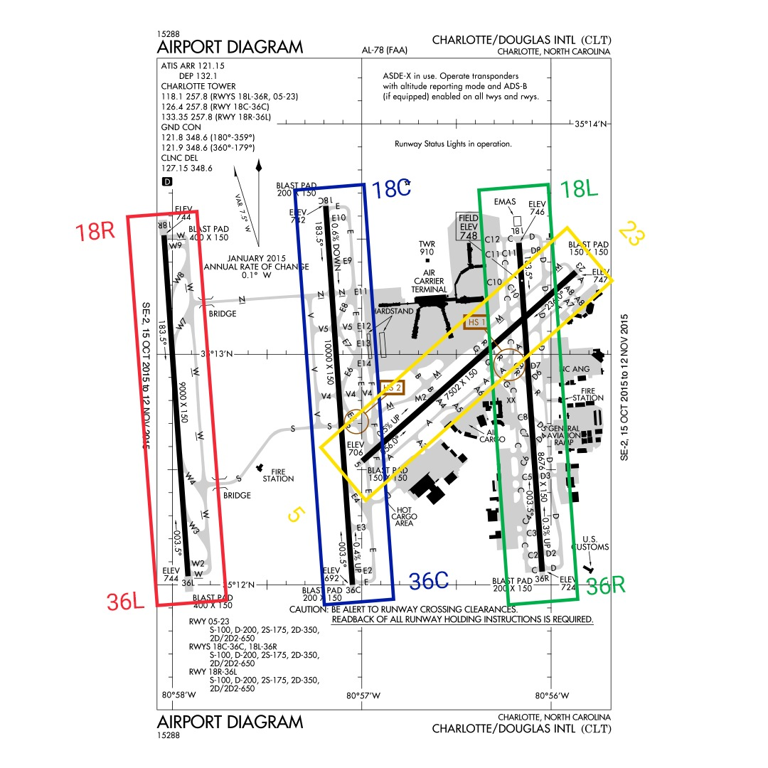

Figure 2: Runways of Charlotte Douglas International Airport, Chicago

Wind Coverage for three parallel runways - 3 West of North

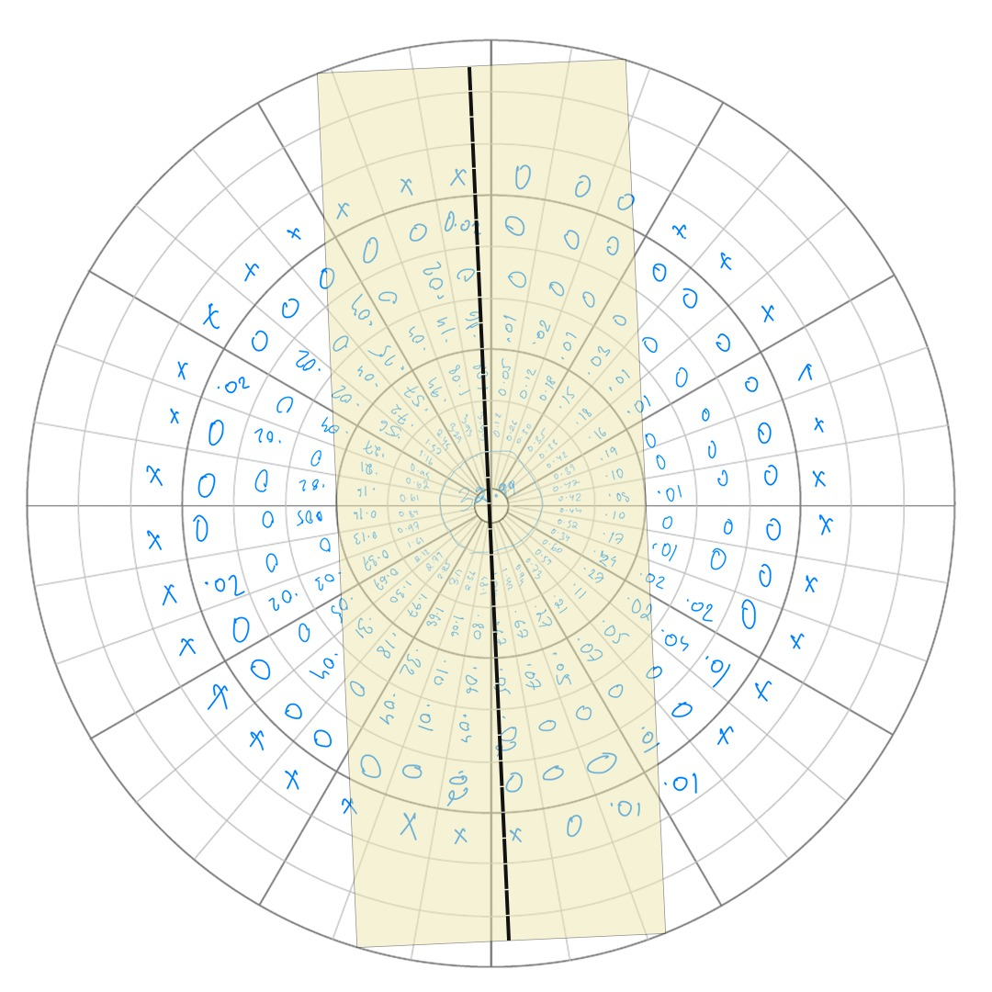

Figure 3: Wind Coverage for three parallel runways

Percentage of yearly coverage for a crosswind of 15 mph for these three runways = 100 – 1.105 = 98.895 %

Wind Coverage for one runway - 55 East of North

Figure 4: Wind Coverage for one runway

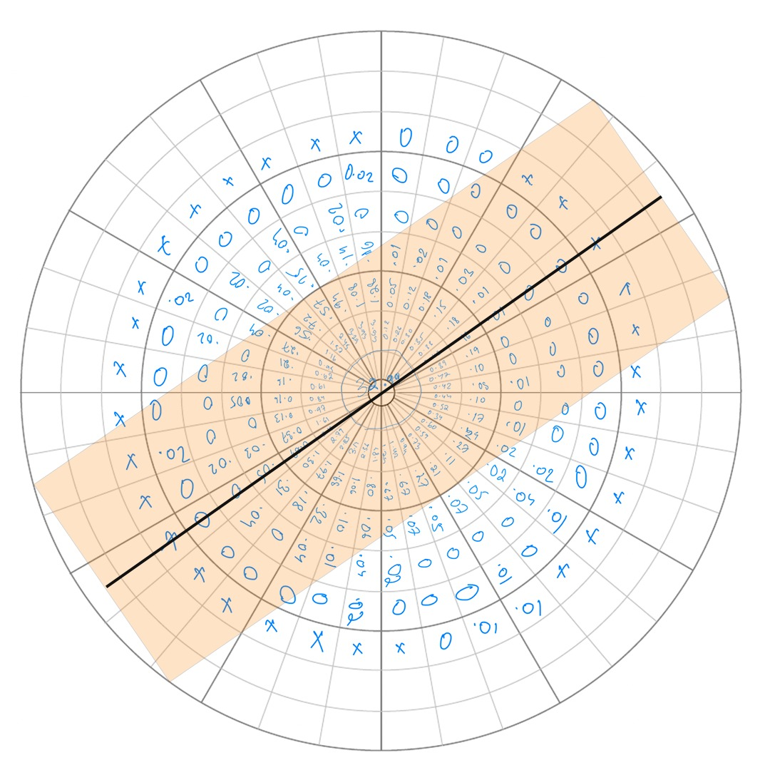

Percentage of yearly coverage for crosswind of 15 mph for the above runway = 100 – 1.042 = 98.958 %

Wind Coverage for cross runways

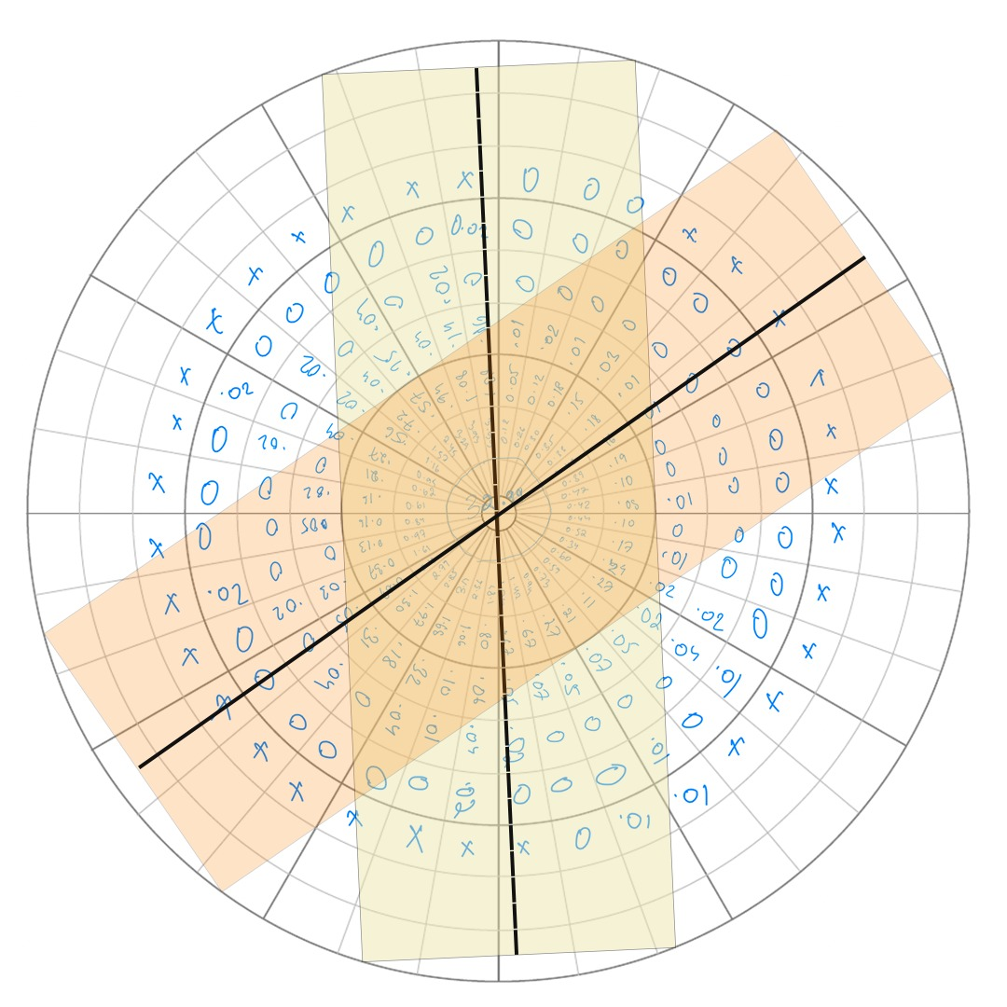

Figure 5: Wind Coverage for cross runways

Percentage of yearly coverage for crosswind of 15 mph for the cross runways = 100 – 0.19 = 99.81 %

# Chapter 2: Declared Distances

## Declared Distances of Runways

**Problem -** Determine the Declared Distances for all the runways of your airport.

**Solution**

The Charlotte Douglas International Airport (CLT) features one crosswind (5/23) and three parallel (18C/36C, 18R/36L and 18L/36R) runways.

Table 3: Declared Distances of all the runways of CLT airport

|  |  |  |  |  |  |
| --- | --- | --- | --- | --- | --- |
| **Runway** | | **Declared Distances** | | | |
| **TORA** | **TODA** | **ASDA** | **LDA** |
| 18C/36C | 18C | 10000 ft/  3048 m | 10000 ft/  3048 m | 10000 ft/  3048 m | 10000 ft/  3048 m |
| 36C | 10000 ft/  3048 m | 10000 ft/  3048 m | 10000 ft/  3048 m | 10000 ft/  3048 m |
| 18R/36L | 18R | 9000 ft/  2743.2 m | 9000 ft/  2743.2 m | 9000 ft/  2743.2 m | 9000 ft/  2743.2 m |
| 36L | 9000 ft/  2743.2 m | 9000 ft/  2743.2 m | 9000 ft/  2743.2 m | 9000 ft/  2743.2 m |
| 18L/36R | 18L | 8676 ft/  2644.45 m | 8676 ft/  2644.45 m | 8676 ft/  2644.45 m | 8676 ft/  2644.45 m |
| 36R | 8676 ft/  2644.45 m | 8676 ft/  2644.45 m | 8390 ft/  2557.27 m | 8390 ft/  2557.27 m |
| 5/23 | 5 | 7502 ft/  2286.61 m | 7502 ft/  2286.61 m | 7092 ft/  2161.64 m | 7092 ft/  2161.64 m |
| 23 | 7502 ft/  2286.61 m | 7502 ft/  2286.61 m | 7502 ft/  2286.61 m | 7502 ft/  2286.61 m |

## Critical Runway

**Problem -** Identify the most critical runway, which has the lowest value of TORA/ TODA/ ASDA/ LDA.

**Solution**

The most critical runway is runway 5 of the crosswind runway 5/23, as it has the lowest value of TORA/ TODA/ ASDA/ LDA, as given below.

TORA - 7502 ft/

2286.61 m

TODA - 7502 ft/

2286.61 m

ASDA - 7092 ft/

2161.64 m

LDA - 7092 ft/

2161.64 m

## Temperature Data

**Problem -** Determine the altitude above the mean sea level for this critical runway and the minimum, average and maximum ambient temperature recorded during January to December 2019.

**Solution**

|  |  |  |  |
| --- | --- | --- | --- |
| **Month** | **Maximum Ambient**  **Temperature (oC)** | **Average Ambient Temperature (oC)** | **Minimum Ambient Temperature (oC)** |
| January | 21.11 | 6.74 | -6.67 |
| February | 25.56 | 10.06 | -17.78 |
| March | 25 | 10.88 | -3.33 |
| April | 29.44 | 17.53 | -0.56 |
| May | 35 | 23.58 | 7.22 |
| June | 33.89 | 24.56 | 11.11 |
| July | 36.11 | 27.21 | 16.67 |
| August | 35 | 25.59 | 15.56 |
| September | 36.67 | 25.81 | 12.22 |
| October | 36.11 | 19.57 | 3.89 |
| November | 21.67 | 9.52 | -5 |
| December | 22.22 | 8.94 | -3.89 |

Table 2.2 : Temperature Data.[3]

Also, the altitude above mean sea level of the critical runway, i.e., runway,5 is **705.9 ft/ 215.16 m**.[1]

## Runway Length Corrections

**Problem -** Estimate the standard value of this critical runway length by incorporating the corrections to be applied due to its altitude above mean sea level, non-ISA ambient temperature, and runway gradient. Use the following table for containing the runway gradients.

|  |  |  |  |  |  |  |
| --- | --- | --- | --- | --- | --- | --- |
| **(In Meter)** | **0-300** | **300-900** | **900-1500** | **1500-1800** | **1800-2100** | **2100-3000** |
| **Gradient (%)** | 1 | -1.1 | 1.6 | 0.2 | 1 | -0.4 |

**Solution**

Basic Runway Length, BRL = 7502 ft/ 2286.61 m

Elevation, E = 705.9 ft/ 215.16 m

Monthly mean of avg. daily temp for hottest month of year (July), T1 = 27.21 OC

Monthly mean of maximum daily temp for same month (July), T2 = 32.88 OC

Airport Reference Temperature, ART = T1 + (T2 - T1)/3 = 29.1 OC

1. **Correction for Elevation**

Elevation correction, Ie = 7% per 300 m rise above MSL.

1. **Correction for Temperature**

Temperature correction, It = 1% per 1oC rise in ART above Standard temperature at that elevation (STE).

Now,

1. **ICAO Check**

Hence, the ICAO check is satisfied and we can proceed for Gradient correction.

1. **Correction for Gradient**

Table 4: Gradient Calculation

|  |  |  |
| --- | --- | --- |
| **Chainage (m)** | **Gradient (%)** | **Rise/ Fall (m)** |
| 0-300 | 0.2+0.1*8 = 1 |  |
| 300-900 | -0.3-0.1*8 = 1.1 |  |
| 900-1500 | 0.8+0.1*8 = 1.6 |  |
| 1500-1800 | 1 – 0.1*8 = 0.2 |  |
| 1800-2100 | -0.6 + 0.2*8 = 1.0 |  |
| 2100-3000 | 1.2 – 0.2*8 = -0.4 |  |

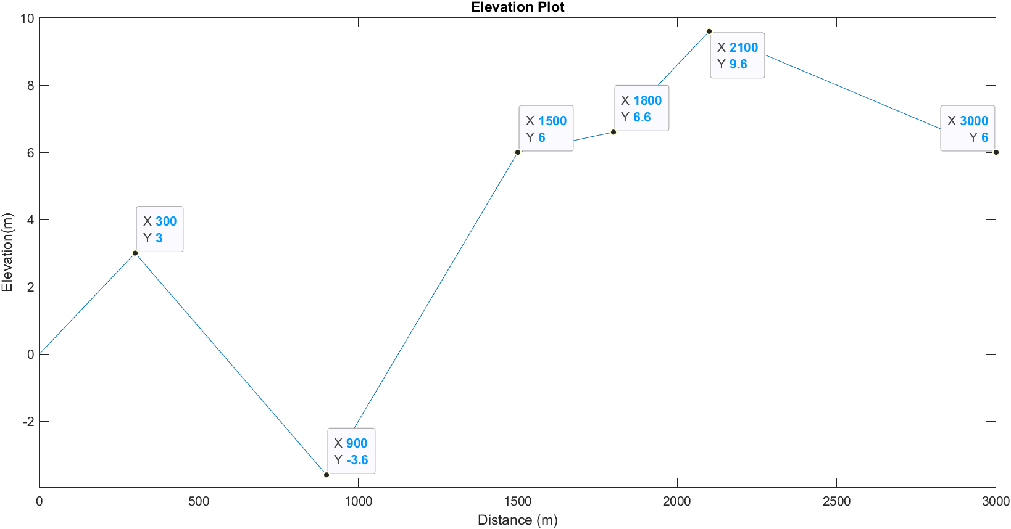

Figure 6: Elevation Plot

Now,

Gradient correction, Ig = 20% for every 1% ELG.

# REFERENCES

[www.airnav.com](http://www.airnav.com)

[www.wilsonair.com/clt-charlotte](http://www.wilsonair.com/clt-charlotte)

[www.wunderground.com/history/monthly/us/nc/charlotte](http://www.wunderground.com/history/monthly/us/nc/charlotte)